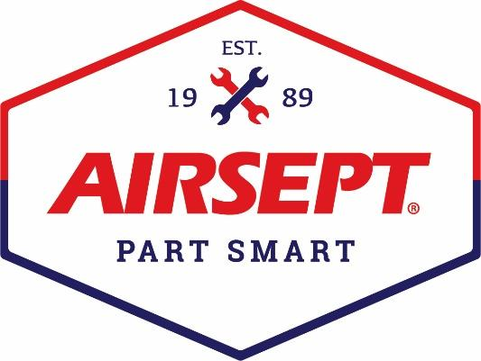

News Release

AirSept® Announces New Distributor - O’Reilly Auto Parts
Two Award-Winning A/C Service Solutions Now Available

Atlanta – July 30, 2024 – AirSept® is pleased to announce a new distribution agreement with O’Reilly Auto Parts. AirSept, a leading manufacturer of solutions for complex automotive repair problems, now offers two of the company’s most popular A/C service products at O’Reilly parts stores nationwide. AirSept’s Dual Recycle Guard™ and Pro Grade Oil and Dye Injectors, both award winning service solutions, can now be sourced through more than 6,000 O’Reilly locations.

AirSept’s Dual Recycle Guard prevents costly repairs and lost service income by removing all sealants and contaminants before they enter expensive A/C service equipment. Internal filters for R134a and R1234yf A/C service machines do not extract sealants and other contaminants before they reach vital internal components. Dual Recycle Guard, a MOTOR Magazine Top 20 Tools award winner, protects a shop’s expensive recycling equipment from potential damage. Compatible with all A/C service equipment, Dual Recycle Guard is sold with all hoses, adapters and couplers included.

AirSept’s Pro Grade Oil and Dye Injector protects technicians from both over- or under-charging a vehicle’s A/C system. The unique sight glass body and easy-to-read measurement scale ensure an accurate oil charge every time. Manufactured with a durable all-steel body for rough service environments and designed for high capacity, the 230 PSI injection force delivers twice the force of other aftermarket injectors. AirSept’s Pro Grade Injector allows technicians to inject oil back into the A/C system either after the vacuum stage or after the recharge stage.

AirSept President Aaron Becker says, “We couldn’t be more thrilled with our new distribution partnership with O’Reilly Auto Parts. This agreement with O’Reilly’s makes AirSept’s unique and innovative service tools and solutions available from one of America’s largest automotive retailers. Our products are designed to save time, improve shop efficiency and increase profits. Our Dual Recycle Guard and Pro Grade Oil and Dye Injector are multiple award winners that are now stocked by O’Reilly to enhance their already impressive tool and equipment lineup. AirSept products will be readily available coast-to-coast from one of the top retailers in the country.”

For more information on AirSept’s full product line available for the automotive aftermarket, visit www.AirSept.com.

# # # #

Image Attached: 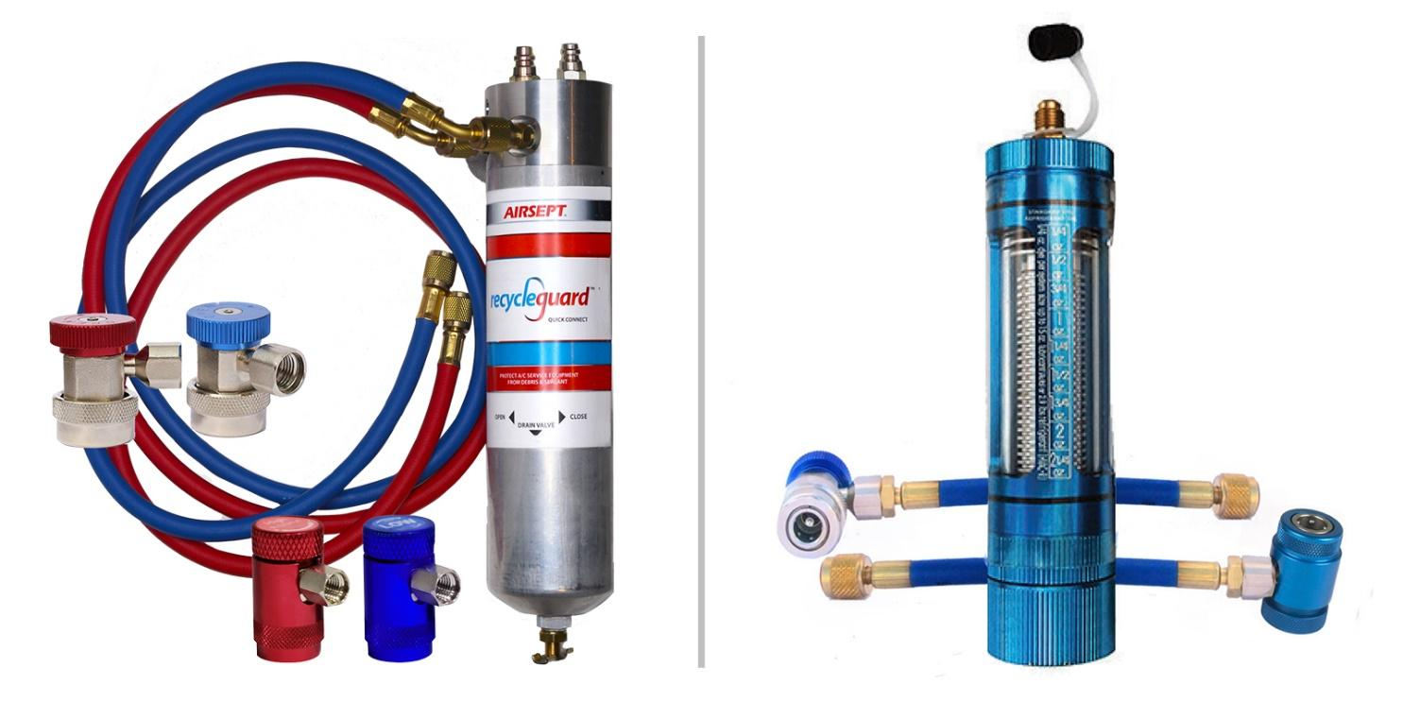
Caption: Left to Right – AirSept Dual Recycle Guard and AirSept Oil and Dye Injector

About AirSept®
In 1989 AirSept® created the first long-lasting solution to the problem of unwanted mold and mildew odor in automobile air conditioning systems. The product quickly became popular and in 1991 AirSept was incorporated as a company. AirSept began partnering with global OEMs and suppliers to not only market its Cooling Coil Coating, but to also develop other unique, new problem-solving products. From those humble beginnings, AirSept has grown to be the industry leader in the development of OEM and aftermarket solutions to complex automotive repair problems. AirSept products are designed to save time, money and labor. For more information, visit www.AirSept.com.

For further information, contact:
Aaron Becker, President
AirSept
678-973-2287
abecker@airsept.com

Leslie Allen
Owner
Wildcat Communications
615-429-7965
leslieallen.wildcat@gmail.com

